Azure Data Engineer: Batch 6

(October 2023)

**Submitted by: Roopmathi Gunna**

# Assignment 1: Storage Account

Question 1

1. Create an ADLS storage account with the name: yourname+yourdob+adls

2. While making ensure it is in the resource group name: - Azurelib-Academy and the region is US-east

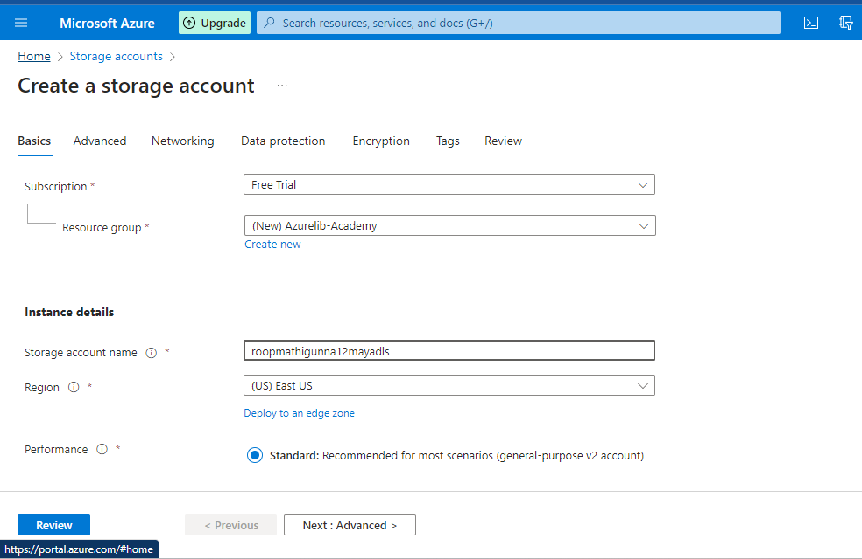

3. Try to change the soft delete time for 7 days to 10 days.

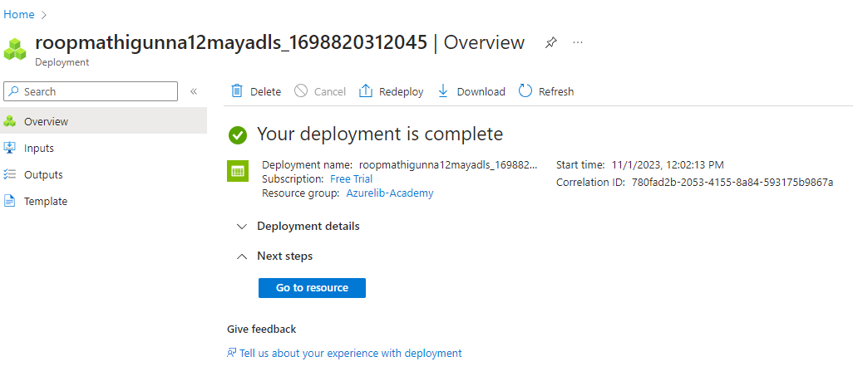

4. Create a container name landing (publicly accessible)

5. Create another container name raw

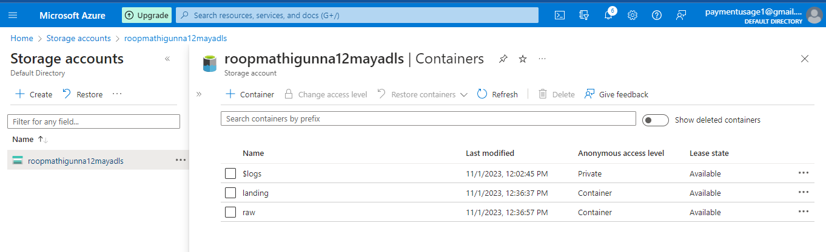

6. Create a directory Practice-1 in both containers

7. Upload any text file in both containers inside Practice-1.

This screenshot shows Test File 1 uploaded to the directory under the Landing container

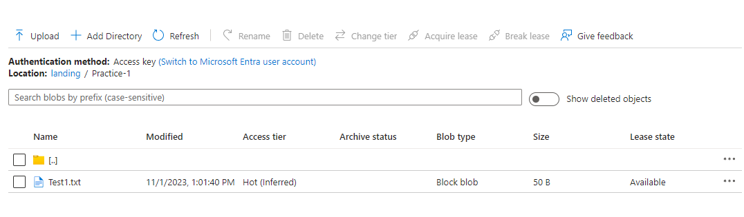

This screenshot shows Test File 2 uploaded to the directory under the Raw container.

8. Delete the file just uploaded

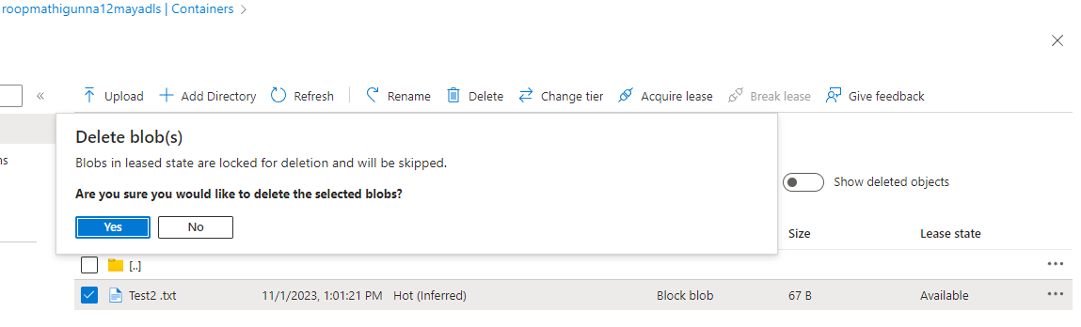

9. Try to restore the deleted file.

We can see that the file is restored.

Question 2:

1. Create a Blob storage account with the name: yourname+yourdob+stg

2. While making ensure it is in the resource group name: - Azurelib-Academy and the region is US-east

3. Try to enable versioning.

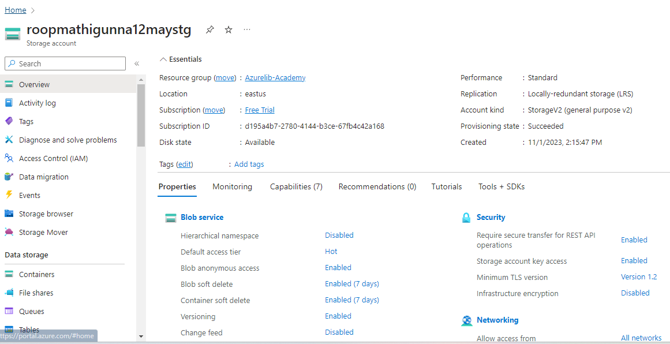

4. Create a container name landing (publicly accessible)

5. Upload any text file in container created recently.

6. Upload same text file again and check if another version is created or not.

Yes, another version is created

Question 3:

1. Go to ADLS account created and try to check the access key for it.

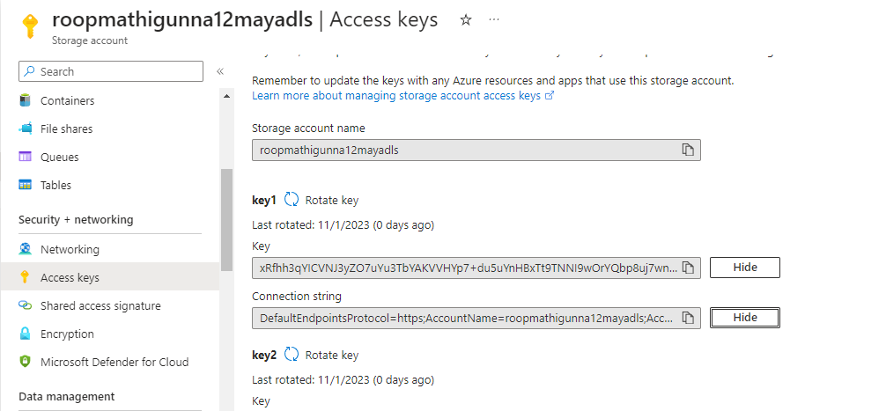

1. Generate a SAS token in such a manner that it has expiry of 7 days and have only read permission.

Question 4:

1. Try to change the access tier of the files you uploaded in the Question 1 from Hot to cold.

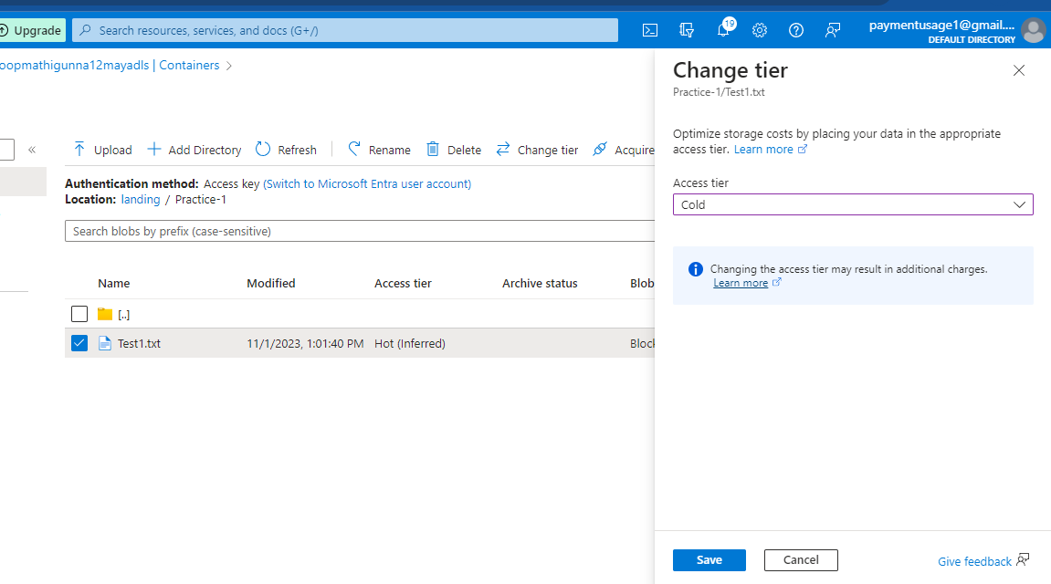

Advance Question

Question 5:

1. Add a rule to ensure that as soon as file becomes more than 30 days old will automatically move to Cold access tier from HOT.

We will do this from the Lifecycle management configuration window on the adls storage account we created in question 1

